NAME: Sharvayu Zade
PRN: 23070521135
SEC: B(B2)

Practical Number 4

Aim: Functions, Scope & Error Handling: Create and invoke functions using declarations, expressions, and arrow syntax. Explore scope and closures. Include try-catch blocks to handle input errors. Write a function to reverse a number and check for palindrome.

Part 1: Functions (declarations, expressions, arrow functions) + Scope + Closures
Part 2: Error Handling + Reverse Number & Palindrome problem

Part 1 – Functions, Scope, and Closures

1. Function Declarations
Definition:
A function declaration defines a named function. It can be called before or after it is defined (due to hoisting).

Syntax:
function functionName(parameters) {
// function body
}

Examples:
// Example 1
function greet() {
console.log("Hello, World!");
}
greet();

// Example 2 – with parameters
function add(a, b) {
return a + b;
}
console.log(add(5, 3));

// Example 3 – returning strings
function welcome(name) {
return `Welcome, ${name}!`;
}
console.log(welcome("Alice"));

// Example 4 – default parameter
function multiply(a, b = 2) {
return a * b;
}
console.log(multiply(5));

2. Function Expressions
Definition:
Functions can be stored in variables. These are not hoisted, so they must be defined before use.

Syntax:
const functionName = function(parameters) {
// function body
};

Examples:
// Example 1
const greet = function() {
console.log("Hello from expression!");
};
greet();

// Example 2 – sum
const sum = function(a, b) {
return a + b;
};
console.log(sum(4, 6));

// Example 3 – anonymous inline
setTimeout(function() {console.log("Executed after 2 seconds");}, 2000);

Explanation
- setTimeout() is a built-in JavaScript function that executes code after a given delay (in milliseconds).
- The first argument here is a function expression without a name → anonymous function.
- The second argument is 2000, meaning 2 seconds delay.
- After 2 seconds, JavaScript calls the anonymous function and prints "Executed after 2 seconds".
Why anonymous?
We don’t give it a name because we don’t need to reuse it — it’s just executed once after the delay.

// Example 4 – named function expression
const factorial = function fact(n) {
return n <= 1 ? 1 : n * fact(n - 1);
};
console.log(factorial(5));

Explanation
- This is a function expression stored in a constant variable factorial.
- The function has a name fact even though we store it in a variable.
This is called a named function expression.
- Why name it?
In recursive functions, the name lets the function call itself inside its own body.
- Logic:
  - If n <= 1, return 1 (base case).
  - Else return n * fact(n - 1) (recursive call).
- Calling factorial(5):
  - 5 * fact(4) → 4 * fact(3) → 3 * fact(2) → 2 * fact(1) → returns 1
  - Result = 120.
Why not just use factorial inside instead of fact?
If you renamed the variable later or passed the function around, the internal name fact would still work for recursion — it’s more stable inside the function body.

3. Arrow Functions
Definition:
Shorter syntax for writing functions. They do not bind their own this.

Syntax:
const functionName = (parameters) => {
// function body
};

Examples:
// Example 1
const greet = () => console.log("Hi from arrow function!");
greet();

// Example 2 – single parameter
const square = n => n * n;
console.log(square(4));

// Example 3 – multiple parameters
const add = (a, b) => a + b;
console.log(add(5, 7));

p// Example 4 – multiline
const isEven = (num) => {
if (num % 2 === 0) return true;
return false;
};
console.log(isEven(8));

4. Scope
Definition:
Scope determines where variables can be accessed.
- Global Scope: Accessible anywhere.
- Function Scope: Accessible inside the function only.
- Block Scope: Accessible only inside { } if declared with let or const.

Example:
let globalVar = "I am global";

function testScope() {
let functionVar = "I am in a function";
console.log(globalVar); // Accessible
console.log(functionVar); // Accessible
}
testScope();
// console.log(functionVar); // Error

{
let blockVar = "I am block-scoped";
console.log(blockVar); // Accessible
}
// console.log(blockVar); // Error

5. Closures
Definition: A closure is created when an inner function remembers variables from its outer function even after the outer function has finished.

Example 1 – Counter

function createCounter() {
let count = 0;
return function() {
count++;
return count;
};
}

const counter = createCounter();
console.log(counter()); // 1
console.log(counter()); // 2

Example 2 – Private Data
function bankAccount(initialBalance) {
let balance = initialBalance;
return {
deposit(amount) {
balance += amount;
return balance;
},
withdraw(amount) {
balance -= amount;
return balance;
}
};
}
const account = bankAccount(100);
console.log(account.deposit(50)); // 150
console.log(account.withdraw(30)); // 120

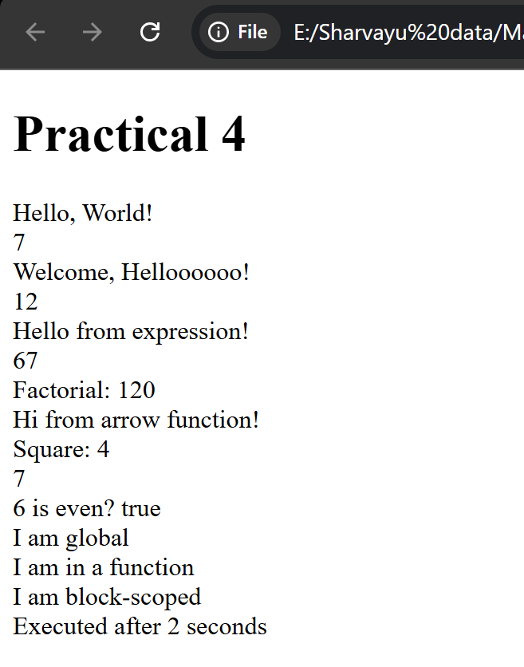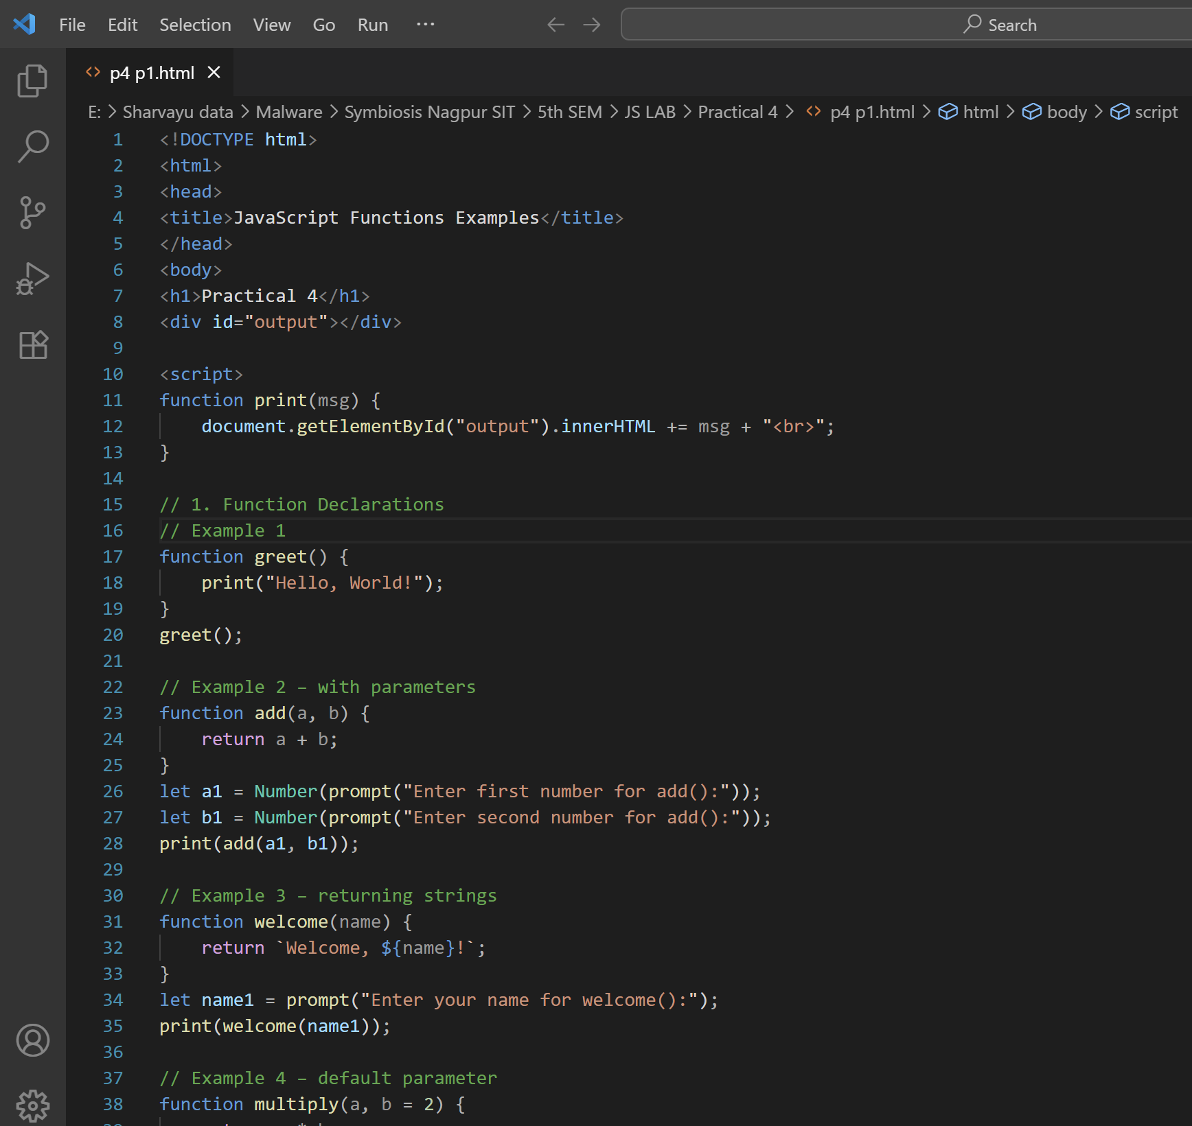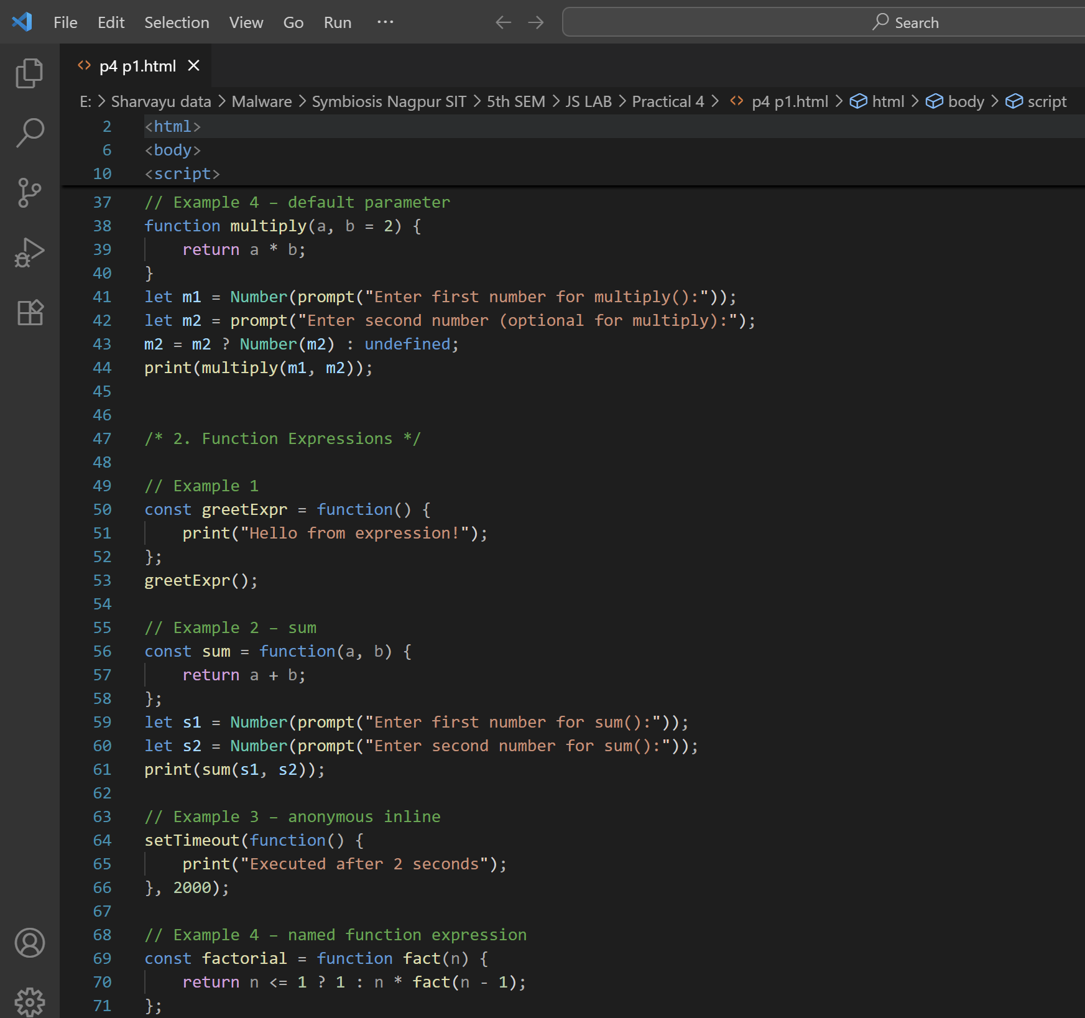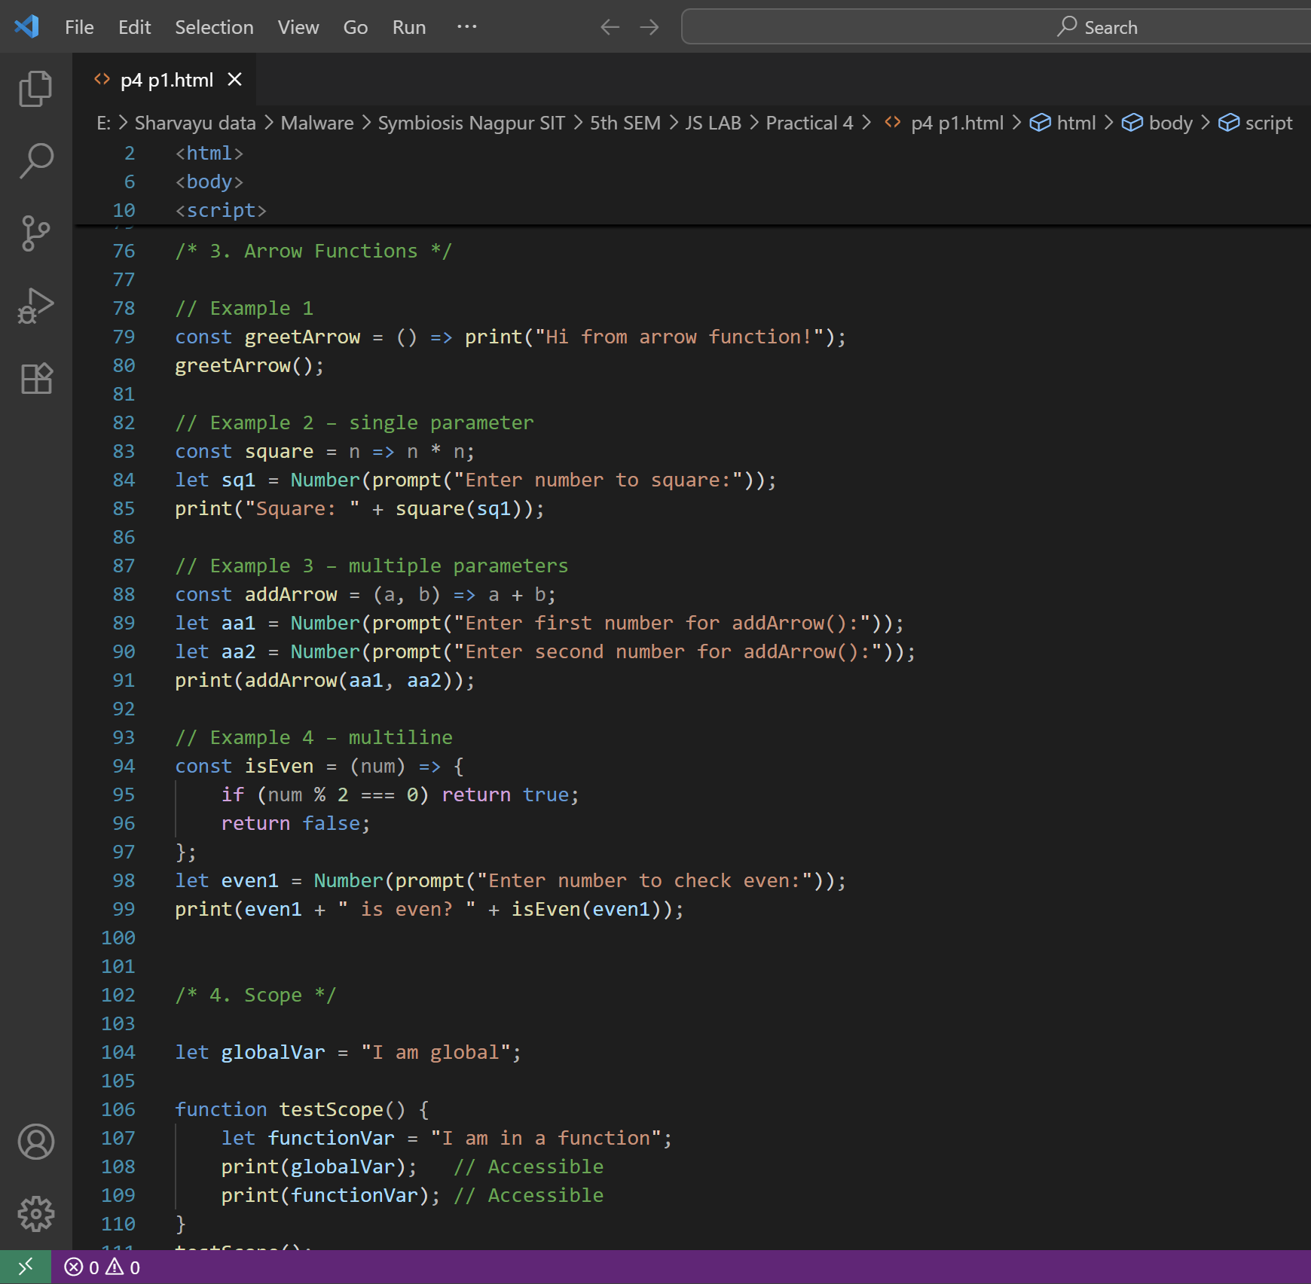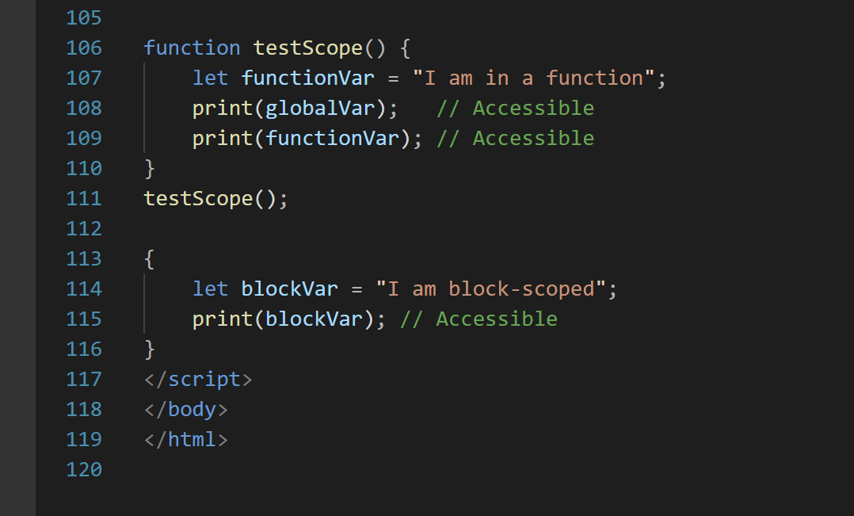

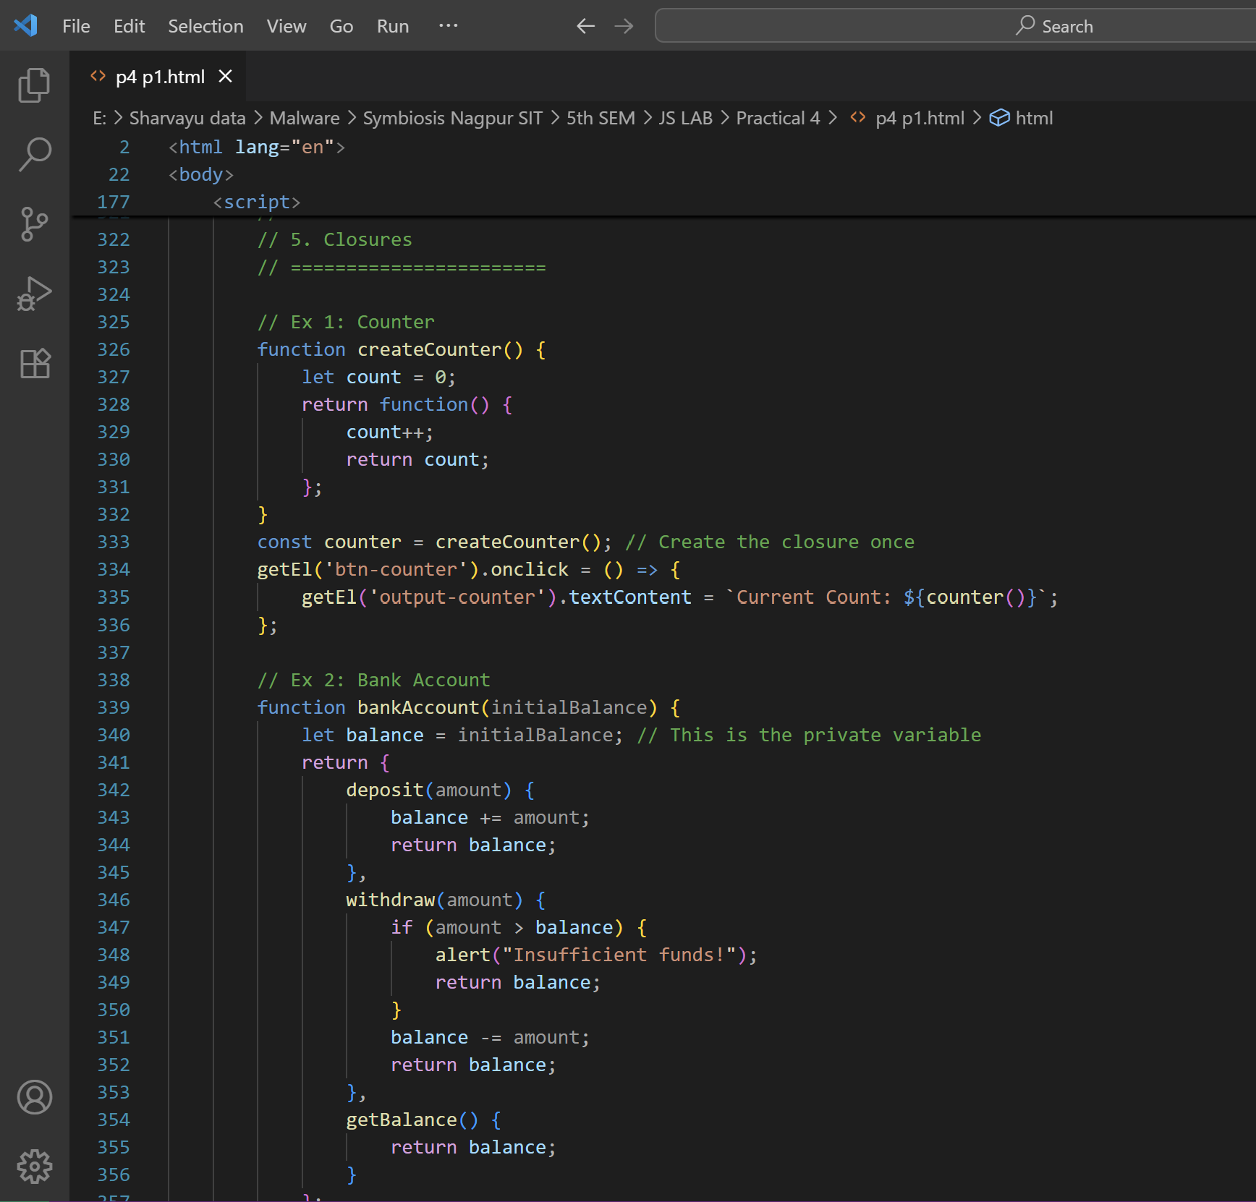
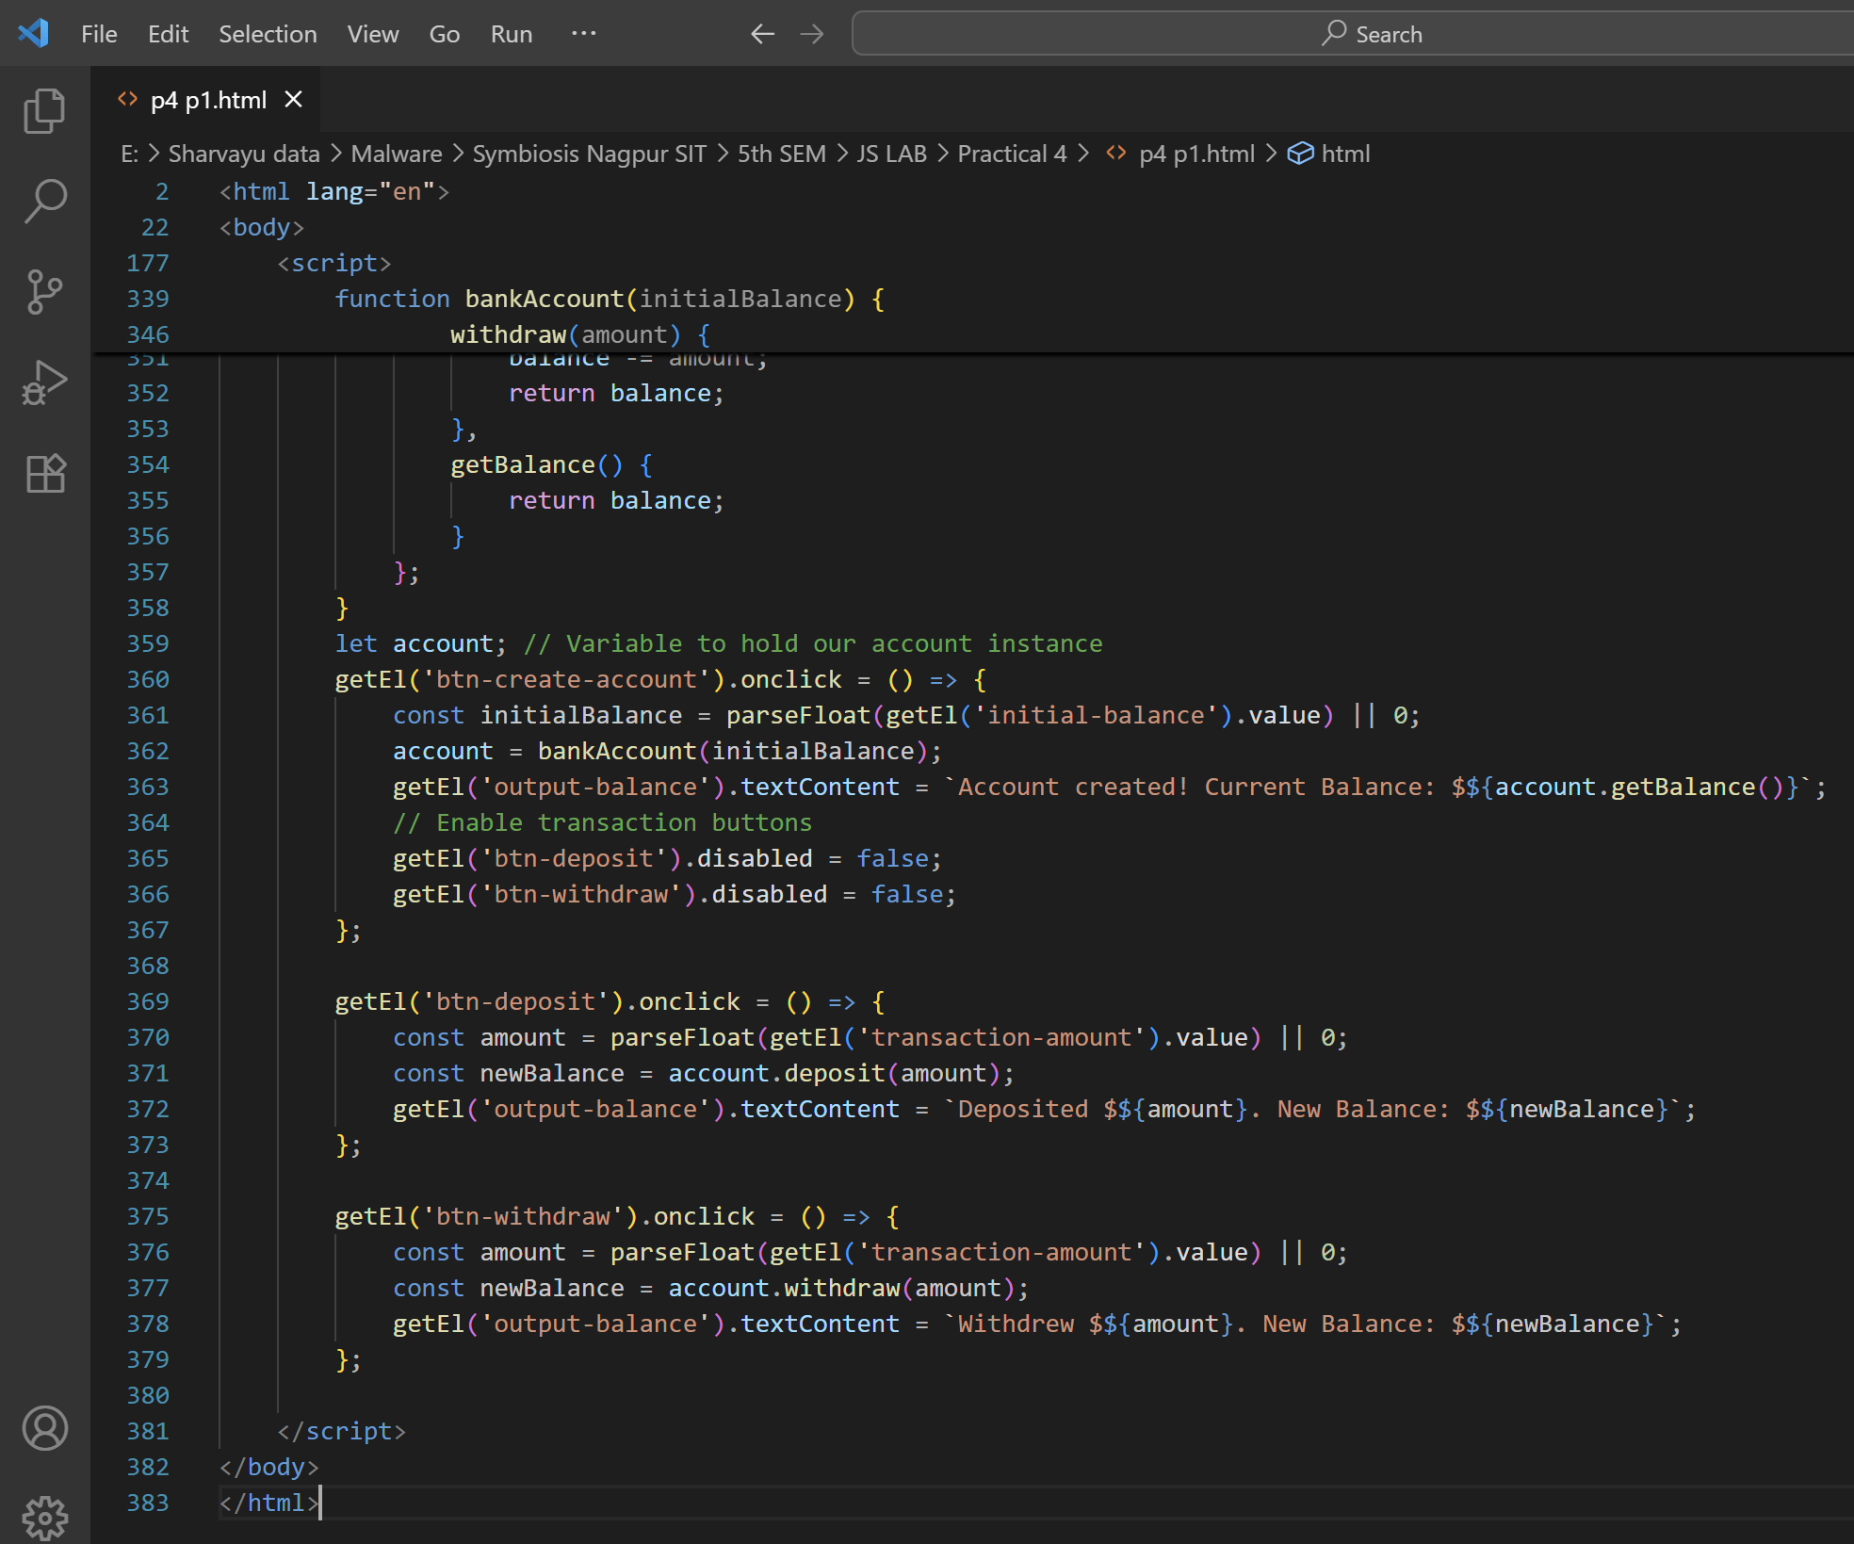

Student Tasks for Part 1
- Write a function declaration that takes two numbers and returns the greater number.
- Write a function expression that calculates the factorial of a number.
- Write an arrow function that checks if a given string contains the word "JavaScript".
- Create a closure that stores a secret message and returns it only when a password matches.
